INFORMATION RISK

TRIAGE TOOL
V202510

Contents
1. Triage Risk Assessment Tool 2
2. Aims 2
3. Scope 2
4. Questions 2
5. Background 3
6. About the data 4
7. About the solution 4
8. Information governance 6
9. Scores 8

Triage Risk Assessment Tool
The tool was based on Lime Survey, however is no longer accessible to users.

Aims
The tool provides a high-level risk assessment of information systems whose score highlights whether further and more detailed information such as Security System Policy is required. It aims to:
- Help Boards achieve compliance with National Security Policy Framework
- Provide a reliable and consistent algorithm to measure information system risk

Questions
The questions are divided into four categories that reflect the tables below: “background questions”, “about the data”, “about the solution” and “information governance”. The tables have the following columns:
- Question code in the questionnaire
- Description includes the question

Background
Question code | Question
B1 | Your name
B2 | Your email
B3 | Your contact number
B4 | Your role in the project in question
B5 | What is the name of the project/information system/data asset?
B6 | Approximate project budget | Table 7 "B6 - Approximate project budget values"
  Value | Answer option
  1 | less than GBP 10k
  2 | GBP 10k - 100k
  3 | GBP 100k - 250k
  4 | GBP 250k - 1m
  5 | more than GBP 1m
B7 | Please describe how the solution is paid for (e.g. source of funding, who is paying?)
B8 | How would you describe the profile of the solution? | Table 9 "B8 - How would you describe the profile of the solution?"
  Value | Answer option
  1 | Low profile, limited exposure and visibility outside of local project team, internal to the health board
  3 | Moderate profile - visibility at SMT or exec level within the health board and/or partner organisations
  4 | High profile - some public engagement, key strategic deliverable for SG/NHSS/health board strategy
  5 | Very high profile - critical success project for the health board, high profile visibility in public/media, key to SG/NHSS/health board strategy
B9 | When is it planned for the solution to go live? | Table 12 "B9 - When is it planned for the solution to go live?"
  Value | Answer option
  1 | Longer than 12 months
  2 | In the next 12 months
  3 | In the next 6 months
  4 | In the next 3 months
  5 | Solution is already live

About the data
Question code | Description
D1 | Data in scope | Table 5 "D1 - Data in scope values"
  Value | Answer option
  1 | Green
  3 | Amber
  4 | Red
  5 | Extraordinarily sensitive
D2 | Volume of personal records
  Table 3 | Value
  No personal record | 1
  between 0 and 1,000 | 2
  between 1,000 and 10,000 | 3
  between 10,000 and 100,000 | 4
  More than 100,000 | 5

(*) We are asking for how many times the app is predicted to be used in year (estimate gross figures)

About the solution

Question code | Description
S1 | Which organisations will access the data? | Table 11 "S1 - Which organisations will access the data?"
  Value | Answer option
  1 | Internal to single NHS Scotland health board only
  3 | Internal to multiple NHS Scotland Boards only
  4 | NHS Boards/Boards in Scotland and partners on SWAN
  5 | Internet facing, public, external partners which are accessible via the public internet, not restricted to internal NHS networks like SWAN and interact with external organisation or individuals outside NHS Scotland.
S2 | High level architecture of the system | Table 14 "S2 - If an information system will be implemented describe the high level architecture”
  Value | Answer option
  1 | No information system (e.g. Only paper records, or access using existing desktop/office e.g. Word, Excel)
  3 | Web based application – users access the system through a standard web browser and no additional software needed.
  4 | Thick client application - software must be installed on end user device (e.g. a desktop application or custom tool).
  5 | Mobile application – primarily accessed via a mobile app that users download from an app store.
S3 | Location of the data hosted | Table 13 "S3 - Where will any parts of the solution or data be hosted?"
  Value | Answer option
  1 | All internal to health board
  3 | Utilising private contracted hosting in the UK
  4 | Utilising shared/cloud hosting in the UK
  5 | Utilising shared/cloud hosting outside of the UK or not sure
S4 | How many users will access the data? | Table 8 "S4 - Approximately how many users will access the system/data?"
  Value | Answer option
  1 | Less than 100
  3 | Between 100 and 1,000
  4 | Between 1,000 and 10,000
  5 | More than 10,000
S5 | Are any aspects of the solution covered by independent security certification?

Information governance
Question code | Description
IG1 | Will personal data be shared with another organisation? | If “yes” then data sharing agreement is required
IG2 | Controls in place | Table 10 "IG2_6 - You have identified, documented and actively manage (e.g. maintain security configurations, patching, updating according to good practice) the assets that need to be carefully configured to maintain the security of network and information systems supporting your essential function(s) (all critical and security patches applied within 14 days. Where a vulnerability is being actively exploited then mitigating action (e.g. patch applied) is immediately taken.  Control Implemented?  - Encryption at rest and in transit Yes / No  - Role-based access controls (RBAC) Yes / No  - Multi-factor authentication (MFA) Yes / No  - Asset management and configuration Yes / No  - Critical and security patches applied within 14 days Yes / No  - Immediate mitigation for actively exploited vulnerabilities Yes / No  - Incident response plan in place Yes / No
  Value | Answer option
  1 | Yes
  5 | No
IG3 | Concerns about the project | - Legacy systems  - known vulnerabilities  - lack of vendor support  - data residency issues  - unclear ownership of data.
IG5 | Will data be processed by third party? Consider supply chain risk:  - Third-party security assessments  - Ongoing monitoring | If “yes” then data processing agreement is required
IG6 PIA | IF any of the PIA questions is YES, a DPIA is required (refer to NHSScotland IG Pack, DPIA template)

IG6 | PIA triage questions | YES/NO
1. | The work involves carrying out a systematic and extensive evaluation of people’s personal details, using automated processing (including profiling). Decisions that have a significant effect on people will be made as a result of the processing.  Includes:  Profiling and predicting, especially when using aspects about people’s work performance, economic situation, health, personal preferences or interests, reliability or behaviour, location or movements  Processing with effects on people such as exclusion or discrimination  Excludes:  Processing with little or no effect on people
2. | The work involves carrying out large scale processing of any of the special categories of personal data, or of personal data relating to criminal convictions and offences.  Includes:  - Racial or ethnic origin data  - Political opinions data  - Religious or philosophical beliefs data  - Trade Union membership data  - Genetic data  - Biometric data for the purpose of uniquely identifying a person  - Health data  - Sex life or sexual orientation data  - Data which may generally be regarded as increasing risks to people’s rights and freedoms e.g. location data, financial data  - Data processed for purely personal or household matters whose use for any other purposes could be regarded as very intrusive  To decide whether processing is large scale you must consider:  - The number of people affected by the processing, either as a specific number or as a proportion of the relevant population  - The volume of data and/or the range of different data items being processed  - The duration or permanence of the processing  - The geographical extent of the processing activity
3. | The work involves carrying out large scale and systematic monitoring of a publicly accessible area. Includes processing used to observe, monitor or control people.
4. | The work involves matching or combining datasets e.g. joining together data from two or more data processing activities performed for different purposes and/or by different organisations in a way that people would not generally expect; joining together data to create a very large, new dataset.
5. | The work involves processing personal data about vulnerable groups. This includes whenever there is a power imbalance between the people whose data are to be used e.g. children, the mentally ill, the elderly, asylum seekers, and the organisation using their personal data.
6. | The work involves the use of significant innovation or emerging technologies, including Artificial Intelligence (AI):  Examples of technology may include:  - Biometric authentication (e.g. fingerprint or facial recognition)  - Internet of Things (IoT) devices  - Artificial Intelligence (AI) systems such as machine learning, natural language processing, or generative AI (e.g. predictive analytics for clinical decision support)  These technologies may involve automated decsion making, profiling or real-time data collection and must comply with UK GDPR and NHS Scotland IG Standards.
7. | The work involves transferring personal data outside the UK?  - Countries with an ‘Adequacy decision’, including EEA countries. You can view an up to date list of the countries which have an adequacy finding on International data transfers | ICO.  - covered by the UK Extension to the EU-US Data Privacy Framework; or  - Covered by Canada’s PIPEDA
8. | The work involves processing that will prevent people from exercising a right or using a service or a contract e.g. processing in a public area that people passing by cannot avoid.

Scores
IMPACT | Score | LIKELIHOOD | Score
D1 | 4 | IG2 | 1
D2 | 2 | S1 | 1
B6 | 2 | S2 | 5
B8 | 3 | S3 | 4
S4 | 1 | B9 | 3
TOTAL IMPACT SCORE | 12 | TOTAL LIKELIHOOD SCORE | 14
Impact score normalised | [A] = (Impact score / 25) * 5  [A ] = 12/25*5 = 2.4 | Likelihood score normalised | [B] = (Likelihood score / 25) * 5  [B] = 14/25*5 = 2.8

RISK = Likelihood * impact = [A] * [B] = 2.4 * 2.8 = 6.72 rounded: 7
Based on the outcome of the risk assessment complete the corresponding next steps.

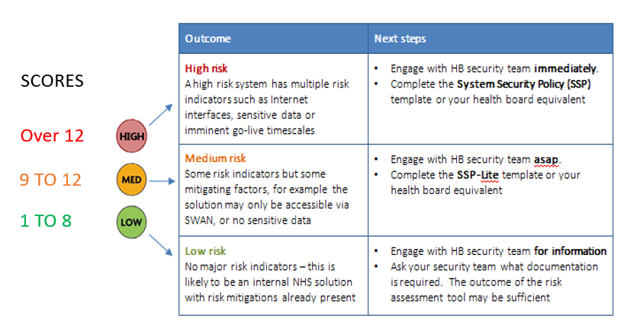
If any of the IG6 (PIA) answers are YES, a DPIA is required (refer to NHS Scotland IG Pack, DPIA template)65554re3ew32dl

