

Information Security

IG Pack

Essential Guidance

A recommended risk assessment approach
V202506

Why I need an IG Pack and when I need it ?
An Information Governance (IG) Pack is a structured set of documents—some based on templates—designed to support those responsible for data and digital initiatives. Whether managing information assets, launching new projects, or requesting access to data, the IG Pack helps ensure that information risks are properly considered and managed across routine services, data flows, and digital technologies.
While IG Packs follow a broadly standardised structure, they are flexible and can be tailored to suit different contexts and levels of complexity. They are especially valuable in multi-organisation settings, offering a common foundation that partners can build on while addressing any local requirements. When developed with a whole-system perspective from the outset, IG Packs are more likely to be adopted consistently, reducing duplication and local rework.

IG Packs also serve as clear evidence of due diligence, supporting accountability in the event of audits or investigations by regulators such as the Information Commissioner’s Office (ICO) or the NIS Competent Authority.
This guidance is designed to support you in preparing an IG Pack by helping you navigate the key assessments and documentation needed to ensure your project or system meets relevant legal and governance requirements before it goes live.
Importantly, data protection regulations require that approval is obtained before processing personal data. In parallel, the UK Network and Information Systems (NIS) Regulations mandate that digital systems used across health and care demonstrate sufficient levels of resilience—that is, the ability to maintain essential services in the face of disruptions, including cyber threats and more routine challenges such as data access delays or performance issues.
Identifying, assessing, and mitigating information security and privacy risks is not only best practice—it’s a legal obligation under both UK data protection law and the NIS Regulations.
This guidance supports a pragmatic approach—where lower-risk activities require lighter IG Packs, helping you scale the effort to the level of risk.
What does it mean to you?
If you're leading a project or managing an information system that handles NHS data, you are responsible for ensuring that appropriate security measures are in place and that your work complies with applicable regulations—such as the UK Data Protection and NIS Regulations.

This guidance is here to support you. It offers practical tools and advice to help you identify and manage information risks effectively. It follows the principle of proportionality: the higher the risk, the more robust your approach should be.
Where can I find the templates and resources mentioned in this paper?
All templates mentioned in this paper can be downloaded from the Digital Health and Care Website (IS Toolkit section):
https://www.digihealthcare.scot/our-work/information-governance-and-assurance-branch/information-sharing-toolkit/the-is-toolkit-approach/

Practical Steps

Step 1 – Triage the overall risk of your project or system
Start by using NHS Scotland’s quick risk triage tool. This tool helps you assess the overall information risk of your project or system by asking a series of simple questions. It generates a report estimating the risk level and recommends appropriate next steps to seek Information Governance (IG) approval.
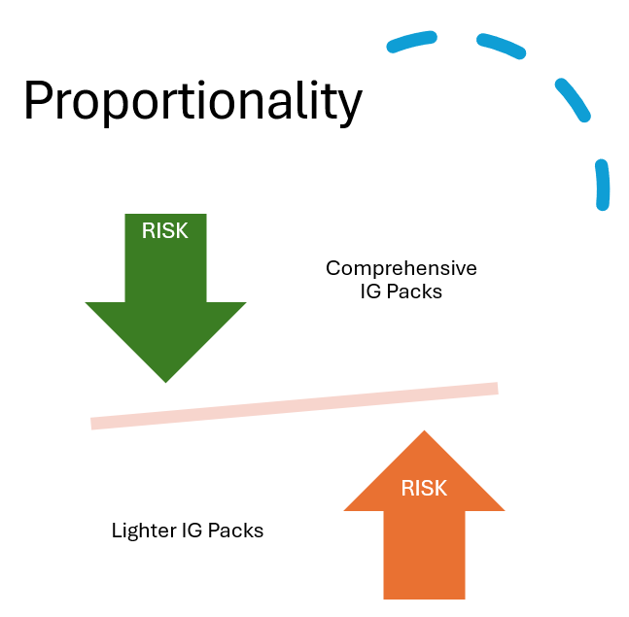
Regardless of the outcome, keep a copy of the triage report as evidence of due diligence and to support your chosen course of action. This approach is rooted in the principle of proportionality—a core element of modern information risk management—ensuring that time and resources are focused according to the level of risk.
The goal is to provide the right level of information to enable informed, risk-based decisions by key stakeholders such as Senior Information Risk Owners (SIROs) and Information Asset Owners (IAOs). For national or high-risk projects, specialist panels like the NHS Scotland Public Benefit and Privacy Panel may also be involved.
All systems processing NHS Scotland data must apply appropriate security measures to reduce risk and protect both data and services, always following the principle of proportionality.

How to use the risk assessment tool
You can access the NHS Scotland online risk triage tool at the link below (restricted access):
🔗 NHS Scotland Cyber Risk Triage Tool
If you don’t have access to the online version, a paper-based alternative is available in the IG Pack under “IGPACK Template for DOC02a Risk Assessment Triage Tool.”
Tip: Your Health Board’s Information Security Officer can support you in completing the triage and help interpret the risk level realistically and appropriately.
Despite its name, the tool goes beyond “cyber” threats—it helps assess the overall information security risk of projects involving digital systems.
It’s important that the risk level is interpreted collaboratively by those with knowledge of both:
- The project or system context
- Information security and governance principles
This avoids over- or under-estimating the level of risk and helps strike the right balance between caution and realism.
Be sure to save or print the triage report, as it forms part of your required evidence of due diligence under UK Data Protection legislation. This documentation is mandatory and may be requested as proof of compliance.
Next step: Follow the actions recommended in your triage report (see next page for an overview).
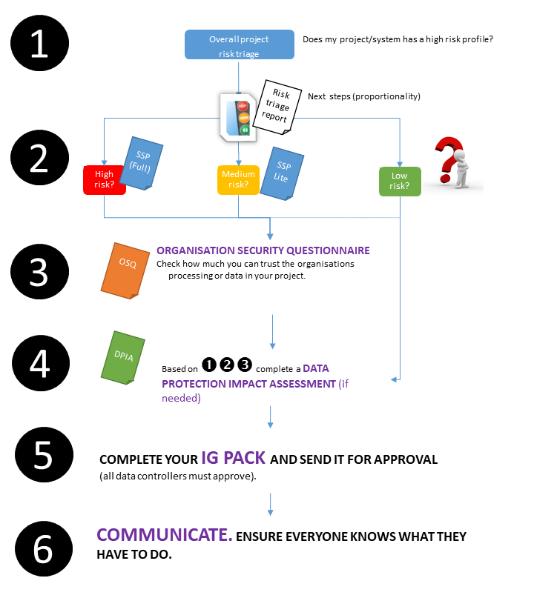
Figure 1 Getting approval for your project. Next steps - a risk based approach.

STEP 2 – Understand the technical security of your system or service
To manage information risk effectively, you need to understand how secure your system or service needs to be from a technical perspective.
This often requires input from others. Your Health Board’s Information Security Officer (ISO) is a key contact who can:

- Help assess the level of technical scrutiny your project requires
- Advise on who else you may need to consult, depending on your project's complexity
For example: If your system uses third-party providers to host servers, deliver web applications, or offer infrastructure-as-a-service, you will need to work with these suppliers to understand the security controls in place across their platforms.
NHS Scotland provides two templates to help document system security:
- System Security Policy (SSP): Required for high-risk or high-profile projects
- SSP Lite: A simplified version for medium-risk projects, and considered good practice for all systems
If you're working with external suppliers, you may ask them to complete the SSP or SSP Lite, or provide an equivalent document in their own format. However, sharing the NHS template helps ensure all required information is captured—enabling your ISO to properly review the system's security posture.
This technical security documentation will be used in Step 4 to assess whether security controls are sufficient and whether any residual risk exists to your organisation or to individuals' privacy, particularly when personally identifiable data is involved.
In summary: Step 2 helps you identify and document the technical security measures in place, laying the groundwork for later risk evaluation and decision-making.

STEP 3 – Assess the organisational security of each party involved
Just as it's important to understand the technical security of your system (Step 2), it's equally critical to assess whether the organisations managing or handling data in your project can be trusted to do so securely.
This step applies to every organisation involved in your system or service, including:

- NHS Health Boards
- Private companies and subcontractors
- Charities
- Local or central government departments
- Other public bodies
This includes any organisation involved in storing, accessing, processing, or transmitting data, either manually or digitally.
How to Assess Organisational Security
You can evaluate the trustworthiness and security maturity of each organisation through a combination of certifications and standard assessments, including:
- ISO 27001 Certification
- Data Security and Protection Toolkit (DSPT)
- Other ways to demonstrate trustworthiness
ISO 27001 Certification
If an organisation claims to be ISO 27001 certified:
- Request a copy of their certificate, the scope of the certification, and the Statement of Applicability (SoA), which outlines the specific controls included.
- Do not assume robust security practices based solely on certification—understanding the coverage and depth of the certification is essential.
- Your Information Security Officer (ISO) can help interpret this documentation, but it is your responsibility to request it from each organisation handling data.
Data Security and Protection Toolkit (DSPT)
The Data Security and Protection Toolkit replaces the previous Information Governance toolkit from April 2018 (NHS England).
The Data Security and Protection Toolkit is an online self-assessment tool that enables organisations to measure and publish their performance against the National Data Guardian's ten data security standards.
All organisations that have access to patient data and systems (NHS England) must use this toolkit to provide assurance that they are practising good data security and that personal information is handled correctly.
Go to the new toolkit for more information, and to access the new service.
Other ways to demonstrate trustworthiness
If an organisation involved in your project does not hold formal information security certifications (e.g. ISO 27001, DSP Toolkit, or NHS IG Toolkit), there are still valid ways to assess their trustworthiness and ability to manage NHS Scotland data securely.
You should consider the following options:
1. Alternative Security Certifications
Ask the organisation whether they hold any other relevant security certifications such as:
- Cyber Essentials / Cyber Essentials Plus
- Other recognised international or industry-specific accreditations
Request:
- A copy of the certification
- Details of the scope (i.e. what parts of their business the certification applies to)
- Results or summary of their most recent assessment or audit

2. Completion of the Organisational Security Questionnaire (OSQ)
Organisations without a recognised certification could complete the NHS Scotland OSQ, which is a standard template designed to gather key information about their organisational security controls and practices.
While not mandatory, completing the OSQ is strongly recommended in the absence of formal certifications, as it provides a structured way to assess whether the organisation has appropriate baseline measures in place to manage and protect data effectively.
3. NIS Regulations Audit
You may also:
- Check if the organisation has been audited under the Network and Information Systems (NIS) Regulations
- Request an extract or summary of the audit findings if applicable
This can provide further assurance of how the organisation manages its systems and critical services in line with UK cyber resilience legislation.
Collecting this information helps you and your Information Security Officer assess whether each organisation involved in your system can be trusted with NHS Scotland data, ensuring decisions are based on evidence and due diligence.

STEP 4 – Data protection legal requirements
You must also check whether your proposed system/project meets any of the data protection conditions listed on pages 3 and 4 of the NHS Scotland DPIA (Data Protection Impact Assessment) template triage table. If any of those conditions apply, completing a DPIA is a legal requirement. You must use the NHS Scotland national DPIA template, available for download from:
👉 The Information Sharing (IS) Toolkit Approach - Digital Healthcare Scotland
A DPIA is not just about listing data, data flows, and security measures. Its main purpose is to assess and document the risks to individuals whose data is being processed, and to the organisation itself, and to ensure that these risks are addressed in a reasonable and proportionate way.
To complete a DPIA, you will need the documents gathered during steps 1, 2, and 3. This is because a DPIA must cover both technical and organisational risks and confirm that appropriate measures are in place to reduce these risks to an acceptable level—one that aligns with your organisation’s risk appetite and complies with current legislation.
The DPIA template also outlines who should be consulted as part of the assessment process. Any identified risks must be acceptable to both the Information Asset Owner (IAO) and the organisation’s Senior Information Risk Owner (SIRO). If not, additional technical or organisational controls may be required.
SIROs are legally required to seek advice from a qualified Data Protection Officer (DPO). In some cases, Caldicott Guardians and other stakeholders—such as the Information Security Officer (ISO)—should also be consulted. In certain organisations, SIROs may delegate decision-making authority to Caldicott Guardians, but this varies by organisation.
For national or multi-board projects, the assessment could be made by the Public Benefit and Privacy Panel (PBPP) on behalf of NHS Scotland Health Boards.
Refer to the diagram on the next page, which illustrates the typical approval pathway for different types of projects, such as research, innovation in telehealth/telecare, and more.

Step 5. Complete your IG Pack and send it for approval.
All relevant data controllers must accept the information risks of your project that are relevant to them as they may hold liabilities, which may be different for the various organisations involved in your project. Give them time to consider their risks and mitigation actions that may be required; involving them from the early stages of the project is highly recommended.

Tip: some practitioners group like the NHS IG Leads Forum, the NHS Caldicott Guardians Forum, the NHS Records Management Forum, the NHS SIROs Forum, could be a way to approach them collectively and agree a collaborative approach. For national projects involving national information assets, or complex or controversial proposals, it is recommended to check

Start by checking with each controller (e.g. via the NHS IG Forum) to determine the appropriate approval route. For national projects involving national information assets, complex or controversial proposals, it is recommended to check with the DHAC (Information Assurance and Risk Team).
- National NHS Scotland projects: Submit to the Public Benefit and Privacy Panel (PBPP), which has delegated authority to review and approve applications on behalf of all NHS Health Boards (see Figure 2). If the panel indicates your project is out of their scope,
- Projects involving multiple controllers (e.g., Scottish Government, local authorities, GP practices): Identify how you will secure approval from each party. You may need to engage key advisory services or groups across these organisations to coordinate sign-off.
- Not sure or your project involves information assets of national interest, or complex or controversial proposals, check with the Digital Health and Social Care Division (Information Governance and Cybersecurity Team) at Scottish Government can advise on the optimal approval pathway. Local Data Protection Officers (DPOs) and Information Governance (IG) Leads can also provide guidance on obtaining any additional approvals.

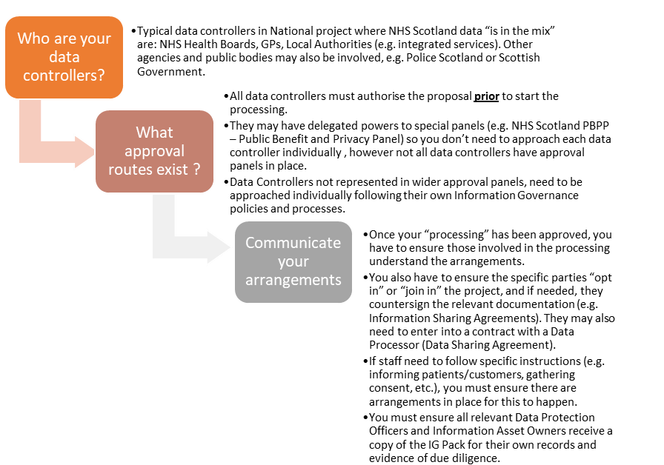

Figure 2 Getting the right approval. Approval process from NHS Scotland data controllers (where NHS Scotland data is in the mix).

What is in the IG Pack.
The IG Pack provides data controllers with all the information they need to understand the proposed processing, the controls in place, and any residual risks—enabling them to make informed decisions and instruct their teams accordingly. Depending on the specifics of each project, an IG Pack typically includes:

- Core documentation
- Additional documentation for high-risk or complex projects
- Technical and organisational security documentation

Figure 3 (next page) illustrates the recommended standardised list of documents belonging to each of these three categories.
By including these documents, the IG Pack ensures that every data controller can review the proposed data flows, security measures, and governance arrangements—and confirm that all requirements (legal, regulatory, and local) have been addressed.

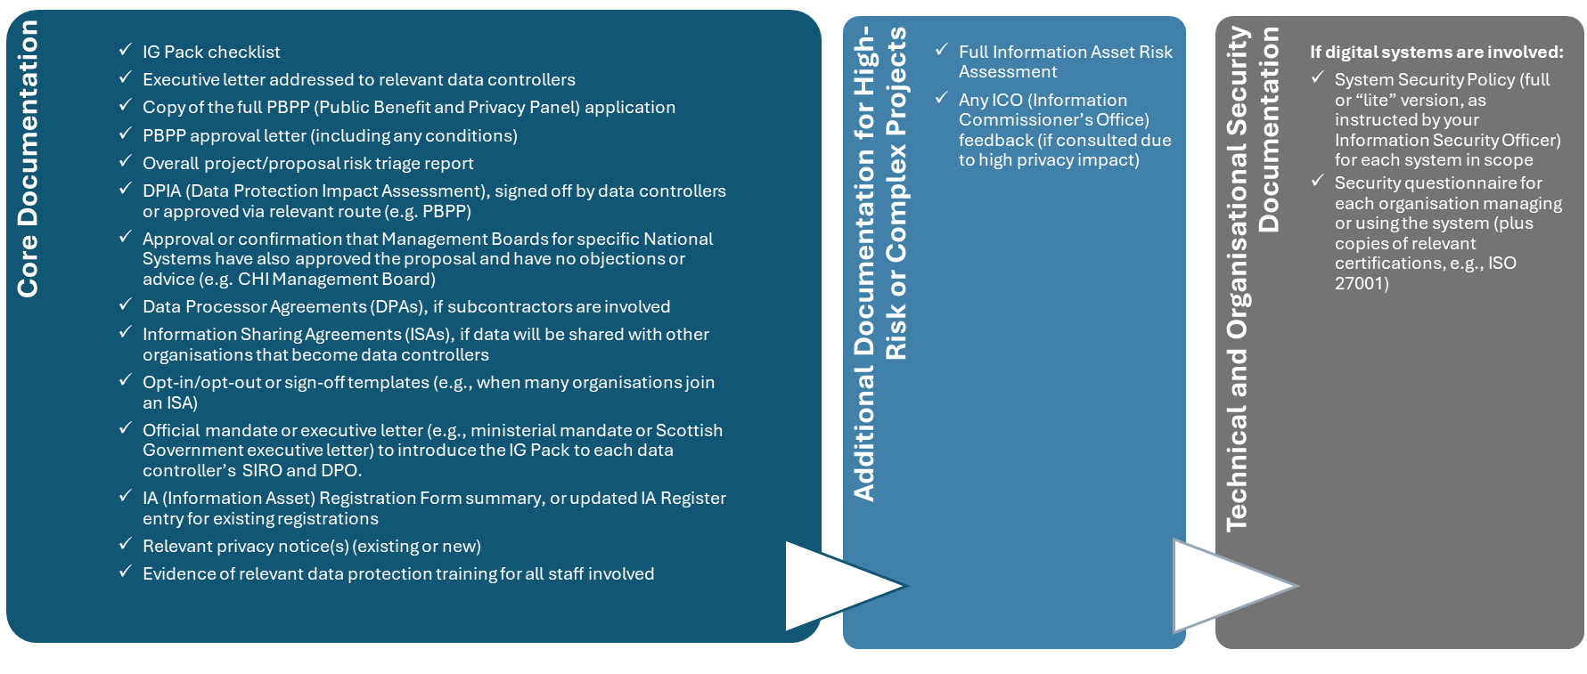
Figure 3 IG Packs standardised content.

What if I have to share data with other organisations?
Sharing data with a subcontractor (data processor)
- You must have a contract in place that includes the required UK Data Protection clauses.
- Seek for a template contract with appropriate data protection provisions, like the template available within the toolkit. You must seek assurance from NHS Scotland Legal Office that all contracts are adequate. For national systems where either Scottish Government or Ministers hold information asset owner responsibilities, check with the Digital Health and Social Care Division (Information Governance and Cybersecurity Team).
Sharing data with other data controllers
- If another organisation will decide – independently or jointly with you – how the data is used, you need an Information Sharing Agreement (ISA).
- Check if there’s already an ISA covering your intended data sharing. For national systems or projects, where either Scottish Government or Ministers hold responsibilities, check with the Digital Health and Social Care Division (Information Governance and Cybersecurity Team). You can also check with
a Data Protection Officer or IG teams within any your data controllers.
- If no suitable ISA exists (or if the existing one is outdated), complete a new ISA. Using the Scottish Information Sharing Toolkit template is highly recommended, as it ensures consistency, includes all required legal and governance clauses, and facilitates quicker review and approval.
By ensuring you have the correct contracts and ISAs in place, you demonstrate compliance with data protection requirements and clarify roles and responsibilities for all parties involved.

Step 6: Communicate: Ensure everyone knows what to do.
Once your IG Pack is complete and approvals have been obtained from all relevant data controllers, it’s vital to make sure everyone involved in data processing understands their responsibilities. This may include:

- Briefing local Data Protection Officers and IG teams on the IG Pack’s contents and any specific requirements
- Notifying Information Asset Owners so they can register (or update) the asset in their local Information Asset Register
- Informing project leads, managers, and operational staff about the agreed arrangements and any instructions they must follow
- Verifying that all local Data Processor Agreements and ISAs are signed and in place
Clear, timely communication helps ensure that everyone is aligned, reducing the risk of misunderstandings and ensuring the IG Pack’s controls are implemented effectively.

https://security.scot.nhs.uk/new-nhs-scotland-cyber-risk-triage-tool/
https://www.digihealthcare.scot/our-work/information-governance-and-assurance-branch/information-sharing-toolkit/the-is-toolkit-approach/
Digital Health and Care Information Governance <DHCIG@gov.scot>

