Data Protection Impact Assessment (DPIA) Questionnaire for

[PROJECT/SYSTEM NAME OR TITLE OF THE PROCESSING ANALYSED]

[INSERT LAST DATE OF THE ASSESSMENT/UPDATE]

DOCUMENT CONTROL SHEET

Title
Date Effective From
Document Type
Document Status
Author
Owner
Approvers
Contact
File Name

Revision History
Version | Date | Summary of Changes

About the Data Protection Impact Assessment (DPIA)
The DPIA (also known as privacy impact assessment or PIA) is an assessment tool which is used to identify, assess and mitigate any actual or potential risks to privacy created by a proposed or existing process or project that involves the use of personal data. It helps us to identify the most effective way to comply with our data protection obligations and meet individuals’ expectations of privacy.

An effective DPIA will allow us to identify and fix problems at an early stage, reducing the associated costs and damage to reputation which might otherwise occur. Failing to manage privacy risks appropriately can lead to enforcement action from the Information Commissioner’s Office (ICO), which can include substantial fines. The DPIA is just one specific aspect of risk management, and therefore feeds into the overall risk management processes and controls in our organisation.

A DPIA is not a ‘tick-box’ exercise. Consultation may take a number of weeks to complete, so make sure that key stakeholders are engaged early, and that your project plan allows for this so that you have enough time prior to delivery to iron out any issues.

Carrying out a DPIA is an iterative process. Once complete, a review date within the next 3 years must be set. Should a specific change in purpose, substantial change in service or change in the law occur before the review date, the DPIA must be updated to include this change.

The ICO code of practice on conducting privacy impact assessments is a useful source of advice.

Is a DPIA required?
If the process or project that you are planning has one or more the aspects listed below then you must complete a DPIA at an early stage.

 |  | YES/NO
2. | The work involves carrying out large scale processing of any of the special categories of personal data, or of personal data relating to criminal convictions and offences.  Includes:  - Racial or ethnic origin data  - Political opinions data  - Religious or philosophical beliefs data  - Trade Union membership data  - Genetic data  - Biometric data for the purpose of uniquely identifying a person  - Health data  - Sex life or sexual orientation data  - Data which may generally be regarded as increasing risks to people’s rights and freedoms e.g. location data, financial data  - Data processed for purely personal or household matters whose use for any other purposes could be regarded as very intrusive  To decide whether processing is large scale you must consider:  - The number of people affected by the processing, either as a specific number or as a proportion of the relevant population  - The volume of data and/or the range of different data items being processed  - The duration or permanence of the processing  - The geographical extent of the processing activity
3. | The work involves carrying out large scale and systematic monitoring of a publicly accessible area. Includes processing used to observe, monitor or control people.
4. | The work involves matching or combining datasets e.g. joining together data from two or more data processing activities performed for different purposes and/or by different organisations in a way that people would not generally expect; joining together data to create a very large, new dataset.
6. | The work involves significant innovation or use of a new technology. Examples could include combining use of finger print and face recognition for improved physical access control; new “Internet of Things” applications.
7. | The work involves transferring personal data across borders outside the countries listed in the ICO website?  - EEA countries  - Countries with an ‘Adequacy decision’. You can view an up to date list of the countries which have an adequacy finding on the European Commission's data protection website.

Step One – Consultation Phase

Consult with all stakeholders about what you wish to do as early as possible in the process. Stakeholders will normally include:
- Key service staff e.g. those who will be managing the process.
- Technical support, especially if a new system is involved. This may involve the relevant IT supplier.
- Information governance advisors e.g. Caldicott Guardian, Information Security Officer, Data Protection Officer.

Sometimes it will be necessary to consult with service users. This will be particularly relevant if the change in process will change how they interact with health and care services, or what information is collected and shared about them.

Early consultation will ensure that appropriate governance and security controls are built into the process as it is being designed and delivered, rather than being ‘bolted on’ shortly before the change is launched.

Step Two- DPIA drafting
The responsibility for drafting a DPIA will normally sit with the service area that ‘owns’ the change, however, all stakeholders will have an input. Depending on the nature and complexity of your proposal, more than one service area and/ or Information Asset Owner (IAO) may be the owner(s).

Step Three- Sign-off
When a DPIA has been fully completed, it must be submitted for formal review by an appropriate IG professional and the Data Protection Officer. They will review the DPIA to ensure that all information risks are fully recognised and advise whether appropriate controls are in place. The Data Protection Officer will decide, where the DPIA shows a high degree of residual risk associated with the proposal, whether it is necessary to notify the ICO. It may be necessary to inform or involve the Senior Information Risk Owner (SIRO) as part of this risk assessment and decision-making.

Once reviewed, the DPIA will need to be signed off by the Information Asset Owner(s) (IAOs), normally a head of service.

Data Protection Enquiries

For enquiries directed to [ADD LEAD ORGANISATION, e.g. The Scottish Government] Data Protection Officer, please contact: [ADD DPO EMAIL, e.g. DataProtectionOfficer@gov.scot]

For escalation of data protection matters with the Information Commissioner's Office (ICO)

For further information, including independent data protection advice and information in relation to your rights, you can contact the Information Commissioner: Website: www.ico.org.uk Tel: 0303 123 1113

You can also report any unresolved concerns here:
“https://ico.org.uk/concerns/handling/.

Examples of DPIAs using this template:

- https://protect.scot/resources/docs/DPIA-3.0.pdf

1 Introduction 3
2 Roles and Responsibilities 3
3 Processing Overview 4
3.1 Systems involved 4
3.1.1 System A 4
3.1.2 System B 4
3.1.3 Other systems. 4
3.1.4 Interoperability (this section can be removed if not relevant) 4
3.2 Disclosures of personal data. 4
3.2.1 Other recipients (anonymous data) 4
4 Scope of Processing 5
4.1 Data Subjects 5
4.2 Personal data 5
4.2.1 Purposes for which personal data is (or will be) used. 5
4.2.2 Data minimization, pseudonimisation and anonymisation. 5
4.2.3 Data retention 5
5 Context of Processing 5
5.1 Design Principles 6
5.2 Privacy Model 6
5.3 Children 6
5.4 Novelty and Robustness 6
5.5 Accessibility 6
5.6 Consultation and engagement. 6
6 Compliance with data protection legislation and other regulatory guidance 6
6.1 Accountability and governance. 6
6.1.1 Governance – data and systems decisions 6
6.2 Lawful basis for processing. 6
6.2.1 Duty of Confidentiality. 6
6.2.2 Automated decision-making 6
6.2.3 Medical devices regulations. 7
6.3 Data Protection rights 7
6.4 Compliance with data protection principles. 7
6.4.1 Principle 1 – fair and lawful, and meeting the conditions for processing 7
6.4.2 Principle 2 – Purpose limitation 8
6.4.3 Principle 3 – adequacy, relevance and data minimisation 8
6.4.4 Principle 4 – accurate, kept up to date, deletion 9
6.4.5 Principle 5 – kept for no longer than necessary, anonymisation 9
6.4.6 Principle 6 – Information Security. 9
6.5 International transfers. 10
7 Risks to data subjects rights and freedoms 10
8 Necessity and Proportionality Assessment 16
9 Approval - Sign-Off 16
9.1 Recommended Review Date: 17
10 Appendix A – Risk scoring system 18
11 Guidance Notes 21

Introduction

Roles and Responsibilities

Table 1 Key organisations and data controllers.
Organisation | indicating briefly their core responsibilities | Decisions they make about the data/processing | Direct processing of personal identifiable data | Data Protection Role

Processing Overview

Systems involved

System A

System B

Other systems.

Interoperability (this section can be removed if not relevant)

Disclosures of personal data.
Personal data is shared with the third parties set out in Table 2 for the purposes/activities mentioned in section 4.2.1 (Purposes for which personal data is used).
Table 2 Disclosures of personal data.
Personal data | Party with whom personal information is shared

Other recipients (anonymous data)

Scope of Processing

Data Subjects

Personal data
Table 3 Personal identifiable data processed.
Personal information | Additional details | Where is this information received from? | Retention

Purposes for which personal data is (or will be) used.
Table 4 Purposes / Activity for which data is used.
Personal information | Purpose / activity / task

Data minimization, pseudonimisation and anonymisation.

Data retention

Context of Processing

This section of the document sets out various contextual aspects of the processing with and impact on the privacy by design and by default approach taken. It also sets the context in regards to privacy concerns that people may have with the processing.

Design Principles

Privacy Model

Children

Novelty and Robustness

Accessibility

Consultation and engagement.

Compliance with data protection legislation and other regulatory guidance

Accountability and governance.

Governance – data and systems decisions

Lawful basis for processing.

Personal Data | Data Controller | Lawful basis

Duty of Confidentiality.

Automated decision-making

Medical devices regulations.

Data Protection rights
There are no fundamental changes to the data protection rights as explained in the NHS Inform website. The Data Protection Act 2018 and GDPR provide individuals with a number of rights relating to their personal data:
Table 5 Data protection rights.
Your data protection right | How to exercise your right
The right to access your personal information.
The right to have personal information rectified if it is inaccurate or incomplete.
The right to have personal information erased and to prevent processing.
The right to 'block' or suppress processing of personal information.
The right to portability.
The right to object to the processing.
Rights in relation to automated decision making and profiling.

Compliance with data protection principles.

Principle 1 – fair and lawful, and meeting the conditions for processing
Article 5(1) of the GDPR says:
“1. Personal data shall be:
(a) processed lawfully, fairly and in a transparent manner in relation to the data subject (‘lawfulness, fairness, transparency’)”
Table 6 Statement of compliance with Principle 1
Lawful, fair and transparent processing
Example
Lawfulness –
- Scottish Government, Public Health Scotland and NHS National Services Scotland, have identified an appropriate lawful basis (or bases) for the processing as well as a condition for processing health data (special categories) (refer to section 7.1).
- None of the data controllers, data processor or their subcontractor do anything generally unlawful with the data.
Fairness
- We (the data controllers) have considered how the processing may affect the individuals concerned and can justify any adverse impact (refer to section 8
- Risks to data subjects rights and freedoms.).
- We only handle people’s data in ways reasonably expected; the app, the privacy notice and this document explain in detail how the data is handled.
- We do not deceive or mislead people when we process their personal data.
Transparency
- Scottish Government, as well as Public Health Scotland and NHS National Services Scotland have been open and honest, and comply with the transparency obligations of the right to be informed.

Principle 2 – Purpose limitation
Article 5(1)(b) says:
“1. Personal data shall be:
(b) collected for specified, explicit and legitimate purposes and not further processed in a manner that is incompatible with those purposes; further processing for archiving purposes in the public interest, scientific or historical research purposes or statistical purposes shall, in accordance with Article 89(1), not be considered to be incompatible with the initial purposes.”
Table 7 Statement of compliance with Principle 2
Purpose limitation
Example :
- Scottish Government has clearly identified the purposes for processing the data in this DPIA (refer to section 5.2.1 Purposes for which personal data is used.) and the Privacy Notice.
- We have documented those purposes in this DPIA.
- We include details of our purposes in our privacy information for individuals.
- We regularly review our processing and, where necessary, update our documentation and our privacy information for individuals.

Principle 3 – adequacy, relevance and data minimisation
Article 5(1)(c) says:
“1. Personal data shall be:
(c) adequate, relevant and limited to what is necessary in relation to the purposes for which they are processed (data minimisation)”
Table 8 Statement of compliance with Principle 3
Adequacy, relevance and data minimisation measures
Look at the example here: https://protect.scot/resources/docs/DPIA-3.0.pdf

Principle 4 – accurate, kept up to date, deletion
Article 5(1)(d) says:
“1. Personal data shall be:
(d) accurate and, where necessary, kept up to date; every reasonable step must be taken to ensure that personal data that are inaccurate, having regard to the purposes for which they are processed, are erased or rectified without delay (‘accuracy’)”

Data accuracy
Look at the example here: https://protect.scot/resources/docs/DPIA-3.0.pdf

Principle 5 – kept for no longer than necessary, anonymisation
Article 5(1)(e) says:
“1. Personal data shall be:
(e) kept in a form which permits identification of data subjects for no longer than is necessary for the purposes for which the personal data are processed; personal data may be stored for longer periods insofar as the personal data will be processed solely for archiving purposes in the public interest, scientific or historical research purposes or statistical purposes in accordance with Article 89(1) subject to implementation of the appropriate technical and organisational measures required by this Regulation in order to safeguard the rights and freedoms of the data subject (‘storage limitation’)”
Table 10 Statement of compliance with Principle 5
Anonymisation and retention.
Look at the example here: https://protect.scot/resources/docs/DPIA-3.0.pdf

Principle 6 – Information Security.
Article 5(1)(f) of the GDPR concerns the ‘integrity and confidentiality’ of personal data. It says that personal data shall be:
'Processed in a manner that ensures appropriate security of the personal data, including protection against unauthorised or unlawful processing and against accidental loss, destruction or damage, using appropriate technical or organisational measures'
Table 11 Statement of compliance with Principle 6
Information Security (Technical and organisational measures)
Look at the example here: https://protect.scot/resources/docs/DPIA-3.0.pdf

International transfers.
No personal data is transferred outside the UK. All data processing will be subject to Data Protection (UK) legislation.

Risks to data subjects rights and freedoms

This section is in response to the guidelines on Data Protection Impact Assessments to determine whether the processing is “likely to result in a high risk”.

The purpose of this section is to determine when the processing operations within the scope of this DPIA, may result in a high risk to the rights and freedoms of people, and thus takes their perspective, as is the case in specific fields (e.g. societal security).

Conversely, risk management in other fields (e.g. information security) is focused on the organisations (the data controllers). The Information Security Risk Assessment referred to in section 6.4.6 (Principle 6 – Information Security.) is focused on the organization; it has been used to inform the risks to the rights and freedoms of people included in this section.

The following separate specialist assessments have also been used to inform the level of risk and countermeasures:
- Medical Devices Regulations
- Data Protection (UK)* and Common Law Duty of Confidentiality
- Human Rights, Fairer Scotland Duty and Equality*
- Children Rights and Wellbeing*
The asterisk indicates an assessment that has been or will be published online as soon as possible. Updates and links will be provided here: [add link]

A summary of the scoring system used for risks in the document is illustrated in Table 12. Further details are available in APPENDIX A – Risk scoring system.
Table 12 Risk scoring system (source: The Scottish Information Sharing Toolkit)
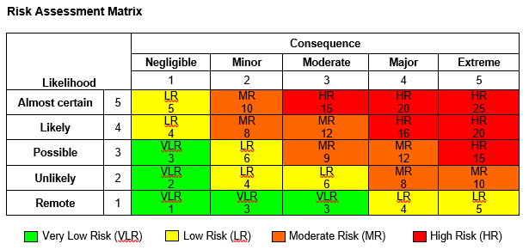

Risk: Unfair and non-transparent processing
Risk |  | Unfair and non-transparent processing.
Impact
Privacy by design and by default notes.
Unmitigated risk score |  | Further mitigation controls | Residual risk score
Likelihood | Unlikely | None. | Likelihood | Remote
Impact | Minor | None. | Impact | Minor
Score | Low Risk | None. | Score | Very Low Risk

Risk: Personal data used for other purposes.
Risk |  | Personal data used for other purposes.
Impact to the data subjects
Privacy by design and by default notes.
Unmitigated risk score |  | Further mitigation controls required | Residual risk score
Likelihood | Unlikely | None | Likelihood | Remote
Impact | Minor | None | Impact | Negligible
Score | Low Risk | None | Score | Very Low Risk

Risk: Exercise of data protection rights.
Risk |  | People cannot exercise their data protection rights.
Impact to the data subjects |  | Unsatisfactory citizen experience with the processing with no clinical outcome/harm).
Privacy by design and by default notes.
Unmitigated risk score |  | Further mitigation controls required | Residual risk score
Likelihood | Unlikely | None | Likelihood | Remote
Impact | Minor | None | Impact | Negligible
Score | Low Risk | None | Score | Very Low Risk

Risk: Unlawful international data transfers.
Risk |  | Risk that personal identifiable data will be transferred to a country with less protections to people’s rights and freedoms.
Impact to the data subjects
Privacy by design and by default notes.
Unmitigated risk score |  | Further mitigation controls required | Residual risk score
Likelihood | Possible | None | Likelihood | Remote
Impact | Minor | None | Impact | Negligible
Score | Low risk | None | Score | Very Low risk

Risk: excessive personal identifiable data
Risk |  | Risk that irrelevant or excessive personal identifiable data is processed by the app.
Impact to the data subjects |  | Unfair processing, restrictions to the privacy of the individual (e.g. identity theft, reversal of anonymous data) and restrictions to people’s freedoms and rights (e.g. no longer voluntary or with more limited choices)
Privacy by design and by default notes.
Unmitigated risk score |  | Further mitigation controls required | Residual risk score
Likelihood | Likely | None | Likelihood | Unlikely
Impact | Major | None | Impact | Minor
Score | High Risk | None | Score | Low risk

Risk: reversal of anonymous data.
Risk |  | Risk that anonymous data can be reversed, identify individuals and expand use of data for unintended purposes.
Impact to the data subjects |  | Unfair processing, restrictions to the privacy of the individual and restrictions to people’s freedoms and rights (e.g. identify and track individuals, financial loss ). Unintended disclosure of data subject data. Undermine confidence in the system/service.
Privacy by design and by default notes.
Unmitigated risk score |  | Further mitigation controls required | Residual risk score
Likelihood | Possible | None | Likelihood | Remote
Impact | Extreme | None | Impact | Minor
Score | High Risk | None | Score | Very Low risk

Risk: prolonged processing of data.
Risk |  | Risk that the app continues processing data longer than justified.
Impact to the data subjects |  | Unfair processing and no-transparent processing leading to limitation of data subjects rights and freedoms.
Privacy by design and by default notes.
Unmitigated risk score |  | Further mitigation controls required | Residual risk score
Likelihood | Possible | None | Likelihood | Remote
Impact | Major | None | Impact | Minor
Score | Moderate Risk | None | Score | Very Low risk

Risk: Anonymisation failure.
Risk |  | Risk that personal identifiable data in not anonymised as expected
Impact to the data subjects |  | Capturing and passing IP address and other identifiers permit the data subject to be identified. This may limit the rights and freedoms of the data subjects and expose the individual to harm (e.g. financial loss, tracking, enforcement of isolation, etc.)
Privacy by design and by default notes.
Unmitigated risk score |  | Further mitigation controls required | Residual risk score
Likelihood | Possible | None | Likelihood | Remote
Impact | Major | None | Impact | Minor
Score | Moderate Risk | None | Score | Very Low risk

Risk: Encryption failure.
Risk |  | Risk that personal identifiable data in not encrypted as expected
Impact to the data subjects |  | Spam, unencrypted data can identify the data subject. Restriction of data subjects rights and freedoms (e.g. tracking, privacy).
Privacy by design and by default notes.
Unmitigated risk score |  | Further mitigation controls required | Residual risk score
Likelihood | Likely | None | Likelihood | Remote
Impact | Moderate | None | Impact | Moderate
Score | Moderate Risk | None | Score | Very Low risk

Risk: Ineffective app operation.
Risk |  | Risk that technical issues with the app may compromise its effective operation.
Impact to the data subjects |  | Reduce user engagement and lessen its effectiveness in providing the expected functionality.
Privacy by design and by default notes.
Unmitigated risk score |  | Further mitigation controls required | Residual risk score
Likelihood | Likely | None | Likelihood | Unlikely
Score | Moderate Risk |  | Score | Very Low risk

Risk: Discrimination
Risk |  | Risk that the app may cause unlawful, unfair or unethical discrimination.
Impact to the data subjects |  | Digital exclusion.
Privacy by design and by default notes.
Unmitigated risk score |  | Further mitigation controls required | Residual risk score
Likelihood | Likely | None | Likelihood | Likely
Impact | Moderate | None | Impact | Minor
Score | Moderate Risk | None | Score | Moderate risk

Risk: Identity theft or fraudulent use of personal data
Risk |  | Risk that personal data can be used to cause harm to the data subject as a result of identity theft or other fraudulent use of personal data.
Impact to the data subjects |  | Financial loss. Adverse consequences for the data subject (e.g. if used for fraudulent activities) that may include damaged credit, tax debt and criminal record.
Privacy by design and by default notes.
Unmitigated risk score |  | Further mitigation controls required | Residual risk score
Likelihood | Possible | None | Likelihood | Unlikely
Impact | Moderate | None | Impact | Minor
Score | Moderate Risk | None | Score | Very Low Risk

Risk: damage to reputation of the data subject
Risk |  | Risk that personal data can be used to damage the reputation of the data subject
Impact to the data subjects |  | Damage to reputation with adverse consequences to the person within their family, friends or work environment.
Privacy by design and by default notes.
Unmitigated risk score |  | Further mitigation controls required | Residual risk score
Likelihood | Possible | None | Likelihood | Unlikely
Impact | Moderate | None | Impact | Minor
Score | Moderate Risk | None | Score | Very Low Risk

Risk: automated processing.
Risk |  | Risk of unconsented automated decisions.
Impact to the data subjects |  | Harm or adverse consequences due to automated processing.
Privacy by design and by default notes.
Unmitigated risk score |  | Further mitigation controls required | Residual risk score
Likelihood | Possible | None | Likelihood | Remote
Impact | Moderate | None | Impact | Negligible
Score | Moderate Risk | None | Score | Very Low Risk

Risk: impact on children
Risk |  | Risk for children below secondary school age using the app
Impact to the data subjects
Privacy by design and by default notes.
Unmitigated risk score |  | Further mitigation controls required | Residual risk score
Likelihood | Possible | Add further FAQs about parental guidance | Likelihood | Possible
Impact | Minor | Add further FAQs about parental guidance | Impact | Negligible
Score | Low Risk | Add further FAQs about parental guidance | Score | Very Low Risk

Risk: impact on people with specific disabilities
Risk |  | Risk of people with specific disabilities using the app
Impact to the data subjects
Privacy by design and by default notes.
Unmitigated risk score |  | Further mitigation controls required | Residual risk score
Likelihood | Possible |  | Likelihood | Possible
Impact | Moderate |  | Impact | Minor
Score | Low Risk |  | Score | Low Risk

Necessity and Proportionality Assessment

This section, presents a reflective assessment of the necessity of the proportionality of the processing described in previous sections, including the measures taken comply with data subject rights, and data protections principles, but also to mitigate any identified risks to the rights and freedoms of people.

Necessity of processing requires that the proposed measures to be introduced will be effective for the objective pursued and whether it is less intrusive compared to other options for achieving the same goal.

On the other hand, the proportionality of processing requires that the advantages of the processing proposed are not outweighed by the disadvantages the measures may cause to a person’s rights, and as such, a balance must be struck between the means used and the intended aim.

[statement of proportionality]

Approval - Sign-Off

[add a summary to make easy the signatories to focus on the overall risk position and who else has reviewed this DPIA , for example:

- Data Protection Officers from the data controllers (Scottish Government, Public Health Scotland and NHS National Services Scotland) have been engaged in the information governance process, providing advice and monitoring its performance pursuant to GDPR Article 35.
- Consultation has been sustained with the Information Commissioner’s Office on a weekly basis.
- The overall risk position of the processing with regards to the rights and freedoms of the data subjects is considered low.
- The overall risk position of the processing with regards to the data controllers organisational risk low except for the overall cyber risk which remains moderate, and the adverse publicity (reputational) risk, which remains high. In this context, it is expected high public and media interest, and questions may be routed to Parliament.
- Having taken into consideration the necessity set out in this document (see section 9 Necessity and Proportionality Assessment), and the limited interference with data subject rights, the processing proposed for the Protect Scotland App is seen as necessary and proportionate.
- No compliance or ethical issues remain outstanding at this point. This will continue to be monitored as the App evolves through the governance structure set up for the App.

Role | Advice/ Action/ Sign-Off | Date
IG/ Data Protection (DPO) Advice
Information Security Officer Advice

Others, if necessary e.g. Caldicott Guardian, Senior Information Risk Owner (SIRO)

DPO opinion on whether residual risks need prior notification to the ICO

Information Asset Owner(s) (IAO(s)) Sign Off

Recommended Review Date:

Appendix A – Risk scoring system

The risk assessments in this document are based on the NHS Scotland guidelines. Further information is available in The Scottish Information Sharing Toolkit.
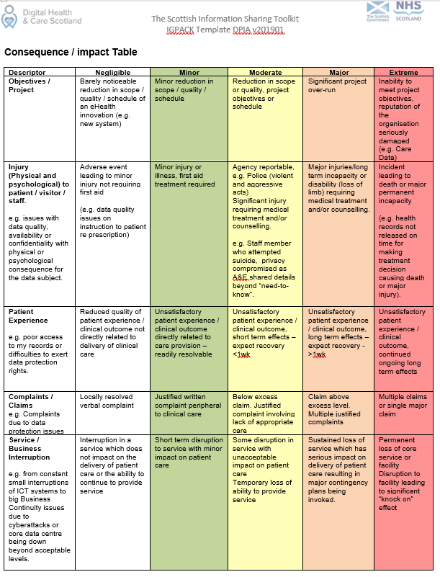
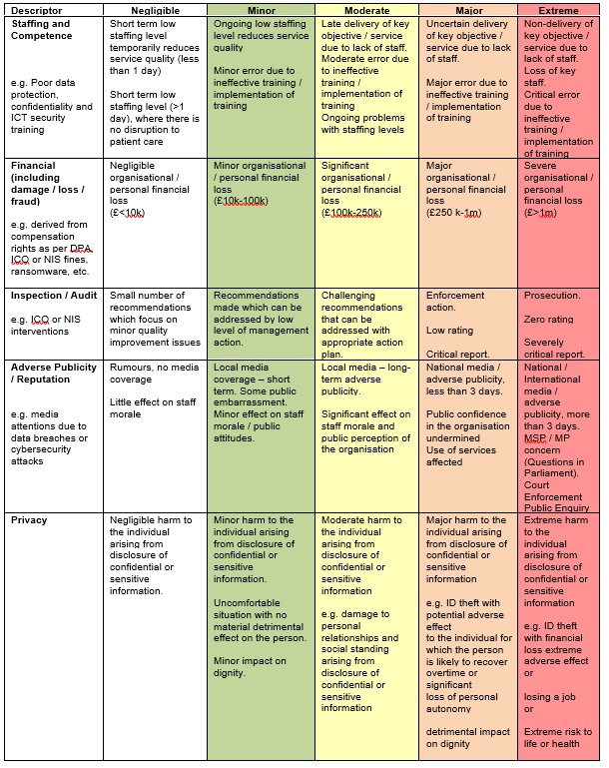
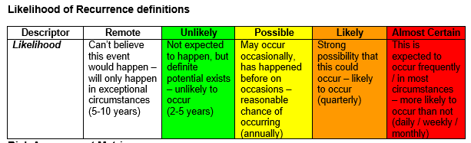
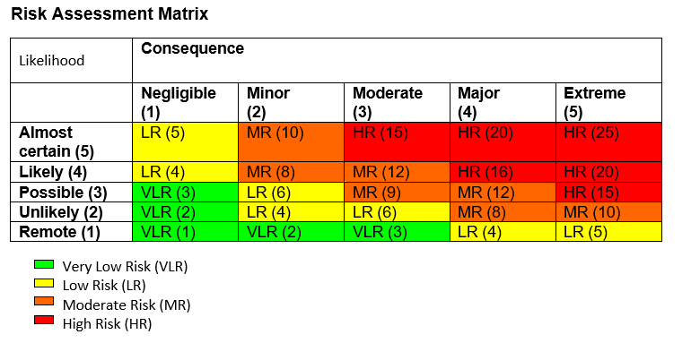

Guidance Notes

Special category personal data
The special categories of personal data are specified in Article 9 of the General Data Protection Regulation and include data about:
- racial or ethnic origin
- political opinions
- religious or philosophical beliefs
- trade union membership
- genetic data
- biometric data for the purpose of uniquely identifying a person
- health
- sex life or sexual orientation.
Personal data relating to criminal convictions and offences should be regarded as having the same special nature as those in the categories listed above.
Legal condition
It is illegal to process personal data without meeting adequately a legal condition.
For personal data which does not relate to any of the special categories (see definition above) the legal basis for the proposed processing must be one or more from the following list. Please note that ‘data subject’ means the person to whom the personal data relates.
- 6(1)(a) – Consent of the data subject
- 6(1)(b) – Processing is necessary for the performance of a contract with the data subject or to take steps to enter into a contract
- 6(1)(c) – Processing is necessary for compliance with a legal obligation
- 6(1)(d) – Processing is necessary to protect the vital interests of a data subject or another person
- 6(1)(e) – Processing is necessary for the performance of a task carried out in the public interest or in the exercise of official authority vested in the controller
- 6(1)(f ) – Processing is necessary for the purposes of legitimate interests pursued by the controller or a third party, except where such interests are overridden by the interests, rights or freedoms of the data subject.
In NHS Scotland, in many cases condition 6(1)(e) will be the most relevant.
For personal data which relate to any of the special categories (see definition above) the legal basis for the proposed processing must be one or more from the following list:
- 9(2)(a) – Explicit consent of the data subject, unless reliance on consent is prohibited by EU or Member State law
- 9(2)(b) – Processing is necessary for carrying out obligations under employment, social security or social protection law, or a collective agreement
- 9(2)(c) – Processing is necessary to protect the vital interests of a data subject or another individual where the data subject is physically or legally incapable of giving consent
- 9(2)(d) – Processing carried out by a not-for-profit body with a political, philosophical, religious or trade union aim provided the processing relates only to members or former members (or those who have regular contact with it in connection with those purposes) and provided there is no disclosure to a third party without consent
- 9(2)(e) – Processing relates to personal data manifestly made public by the data subject
- 9(2)(f) – Processing is necessary for the establishment, exercise or defence of legal claims or where courts are acting in their judicial capacity
- 9(2)(g) – Processing is necessary for reasons of substantial public interest on the basis of Union or Member State law which is proportionate to the aim pursued and which contains appropriate safeguards
- 9(2)(h) – Processing is necessary for the purposes of preventative or occupational medicine, for assessing the working capacity of the employee, medical diagnosis, the provision of health or social care or treatment or management of health or social care systems and services on the basis of Union or Member State law or a contract with a health professional
- 9(2)(i) – Processing is necessary for reasons of public interest in the area of public health, such as protecting against serious cross-border threats to health or ensuring high standards of healthcare and of medicinal products or medical devices
- 9(2)(j) – Processing is necessary for archiving purposes in the public interest, or scientific and historical research purposes or statistical purposes in accordance with Article 89(1)

In many cases condition 9(2)(h) will be the most relevant for NHS Scotland organisations. The Information Commissioner’s Office (ICO) advises that public authorities will find using consent as a legal basis difficult. So if the proposed processing is to use consent as its legal basis you need to indicate why this is necessary and seek the advice of an appropriate IG professional.
Data Processor
Article 4 of the General Data Protection Regulation defines a Data Processor as a natural or legal person, public authority, agency or other body which processes personal data on behalf of the Data Controller. In practice it includes organisations and companies that provide services such as records storage, transport and destruction and IT services, where we ask them to carry out specific tasks using personal data on our behalf. IT suppliers, even if only accessing data/systems for support issues or bug fixes, are legally defined as a Data Processor. Data Processors may only be used to process personal information where they have provided sufficient guarantees to implement appropriate technical and organisational measures to comply with the law.

Based on the ICO checklists. https://ico.org.uk/for-organisations/guide-to-data-protection/guide-to-the-general-data-protection-regulation-gdpr/key-definitions/controllers-and-processors/ and the EDPB Guidelines 07/2020 on the concepts of controller and processor in the GDPR.
This refers to sharing data with data processors, other data controllers, third parties or with other areas within the organisation separate from areas initially considered involved in the processing for which the data was originally collected.
WP 248 - Guidelines on Data Protection Impact Assessment (DPIA) and determining whether processing is “likely to result in a high risk” for the purposes of Regulation 2016/679.
https://www.informationgovernance.scot.nhs.uk/istresources/
https://www.informationgovernance.scot.nhs.uk/istresources/

